PROJECT GUIDELINES

SCOPE
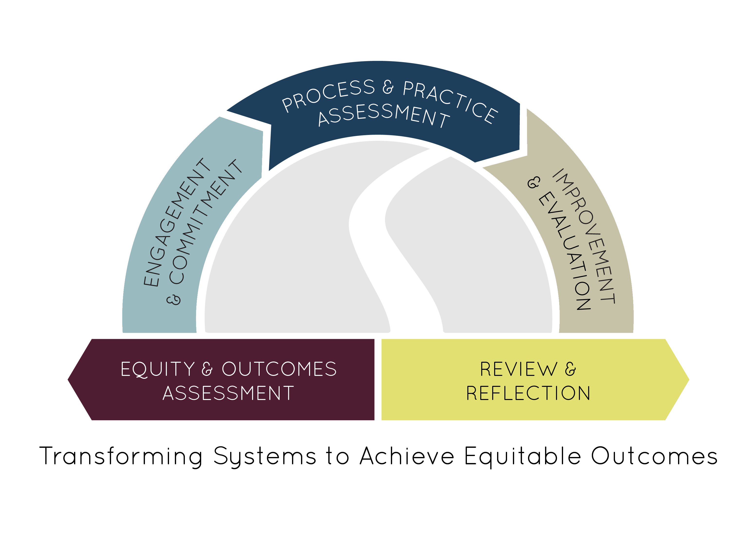
The Pathways to Results (PTR) year one project, Partnership and Planning for Student Success, aims to assemble a meaningful plan for implementing an evidence-based improvement that addresses documented gaps in students’ equitable outcomes. Different than in years past, teams’ PTR work will be concentrated through participation in an intensive two-day institute requiring both pre-work and follow-up conference calls to prepare for the final deliverable—an intervention plan that is eligible to be considered for a Year Two PTR grant that supports implementation and scaling. This project will support teams interested in improving educational outcomes and student transition to and through a pathway and programs of study including:
- Developing an engaged stakeholder group and representative team inclusive of faculty, student affairs, and academic affairs leaders, in addition to secondary and industry partners.
- Using student-level data (quantitative and qualitative) to identify outcomes gaps and create a targeted, evidence-driven vision for improving equity in the pathway.
- Analyzing core processes (e.g., recruiting, advising, teaching, learning) and student support practices (e.g. first year experiences, college success courses, intrusive advising) that contribute to the identified issue.
- Proposing a potential improvement or improvements for implementation.

More information on the Pathways to Results continuous improvement process is available at: http://occrl.illinois.edu/projects/pathways/.

OBJECTIVES

Colleges are required to select one of the following focus areas:

- Perkins Deficient Performance Measure: PTR teams will start to address a deficient Perkins measure by gathering and analyzing data pertaining to low performing subgroups, with a special interest in underserved student groups.
- Retention: PTR teams will examine significant issues of retention in pathways and programs of study. Teams may also consider projects that examine retention in more than one pathway to identify larger trends or issues.

- Program Review: PTR teams will apply the processes of PTR to program review or other institutionalized continuous improvement processes.
- Transfer Pathways: PTR teams will examine outcomes relative to student transfer to related four-year programs.
- Adult Career Pathways: PTR teams will attempt to transform pathways for adult learners to and through completion of a pathway and credentials.
- Secondary to Postsecondary Transitions: PTR teams will attempt to transform pathways for students from high school into the community college.

DELIVERABLES
- Assemble a core team of 4 or more team members who are committed to working on a specific student pathway. Representation on the team should include secondary, postsecondary, and industry.
- Participate in one pre-institute webinar to prepare for the institute.
- Bring a team of at least four core members to attend the Pathways to Results Intensive Institute to take place in April 5-6 in Bloomington, IL to complete the Engagement and Commitment, Equity & Outcomes Assessment, and Process and Practice Assessment processes on site.
- Participate in three follow-up and planning calls, one per month in April, May, and June with OCCRL to support final planning and data collection processes.
- Create a final, brief project profile and a plan for the team to implement a pathway improvement. This plan may be used as an application to receive year two, implementation funding (subject to funding and availability).
TECHNICAL ASSISTANCE
Regular technical assistance during the grant period will be provided by ICCB CTE and OCCRL staff.

FUNDING SOURCE & PERIOD
This project will provide funding, flowed through OCCRL to reduce administrative overhead, for team participation in the Intensive Pathways to Results Institute. Conference and hotel fees, meals, materials, and consulting fees for the institute and technical assistance through June 30th will be provided to all grant recipients from Illinois Community College Board Federal Perkins Leadership funds. Funding for mileage to the institute may also be covered as needed. Participation in this supported institute will qualify participating project participants to apply for PTR Year Two Implementation Grants.
How to Apply: All applications should be submitted to Natasha Piper at natasha.piper@illinois.gov by February 12, 2016. Please cc Heather McCambly at mccambly@illinois.edu.

GRANT PROPOSAL
COLLEGE:

Primary Contact
Name/Title
Telephone/Email
Focus
Please select your focus. You must choose only one focus area.
☐ |  | Perkins Deficient Performance Measure  ☐1P1 Technical Skill Attainment  ☐2P1 Credential, Certificate, or Degree Completion  ☐3P1 Retention or Transfer  ☐4P1 Student Placement  ☐5P1 Nontraditional Participation  ☐5P2 Nontraditional Completion
☐ |  | Retention
☐ |  | Program Review
☐ |  | Transfer Pathways
☐ |  | Adult Career Pathways
☐ |  | Secondary to Postsecondary Transitions
Narrative
Complete the following sections.
Rationale
Explain why you selected the particular focus area.

Problem Statement
Identify the areas in which there is a problem or an opportunity for improvement. (If you selected program review, explain how you envision the PTR process will be incorporated into and compliment your existing review process.)
Pathways or Programs of Study
List any pathways or program(s) of study that would be examined and/or affected.
Prior Experience
Please explain what your prior experience has been with the PTR process.
Student Population
Please describe your college’s interest, if any, in addressing issues affecting a particular student subgroup. For example, improving pathways and outcomes for underserved student groups or a particular special population.

These funds are tied to programs of study as outlined in the Carl D. Perkins Career and Technical Education Act of 2006 (Perkins IV) and include: - Incorporation of secondary to postsecondary educational elements; - Alignment between academic and CTE content in a coordinated, non-duplicative sequence; - Opportunity for dual or concurrent enrollment; and - Attainment of an industry recognized credential, certificate, or degree

